WCR Checkoff Program
Ideas for how to communicate about the Checkoff Program with your roaster clients

We encourage you to promote the Checkoff Program to your clients and share your role as a partner in our work. Below are resources and ideas to get you started.

How does the WCR Checkoff Program work?

The Checkoff Program is a way for Suppliers and Roasters/Retailers to invest pennies per pound (cents per kilogram) to ensure the future of coffee. The contribution is calibrated to roasters’ and retailers’ purchase volume and built into the cost of green coffee.

Limitations: Because of the high cost associated with administering the Checkoff program, it is available only for roasters purchasing more than 50,000 pounds of green coffee per year from participating suppliers. (See full membership fee schedule at the link below.)

*

Ideas for how to communicate about the WCR Checkoff program

- Sales Reps can discuss WCR Checkoff program during sales calls or meetings with new clients
- Share a Welcome Packet with prospective and new clients, including information about WCR and the Checkoff Program
- Add language about WCR to your website sustainability page
- Write a blog post about the Checkoff Program and/or WCR’s recent work
- Send an annual email inviting current roaster clients to sign up for the Checkoff program
- Highlight the partnership with WCR and the option to participate in the Checkoff program option in your client newsletter
- Post on social media channels about your partnership with WCR and the option to sign up for the Checkoff Program a few times per year

*

Resources

- Brand Assets. Importers that participate in the Checkoff Program are entitled to use our brand assets in their communications. This page contains logos, photo images, communication ideas, and key messaging points.
- About WCR FAQ. A brief 2-page overview of why WCR exists, what we do, and how we work, in a simple-to-read FAQ format. Ideas for use: Share it with your sales and marketing team so they have an understanding of what WCR does and how to talk about the you can share with clients.
- About WCR 1-pager. A beautiful, ready-to-use flier explaining WCR’s work. Ideas for use: Adapt the flier contents on your website sustainability page. Send an email with this flier attached to your roaster clients and encourage them to sign up for the Checkoff Program.
- Membership fee structure. Details about the pricing and fee structure of WCR membership.
- Membership benefits. Details about the benefits to support WCR members and engage them in this collaborative industry effort.
- WCR new annual report. Includes stories and updates on our progress. Ideas for use: Adapt content from the annual report for your blog or client newsletter.

*

Sample language for sales calls
(should be adapted to each company’s process)

- “Are you interested in learning about how an additional penny per pound can contribute to essential agricultural science in support of coffee and coffee farmers?”
- “Would you be interested in learning more about some of the partnerships we have that enable you to add impact to your green coffee purchases?”
- “We partner with World Coffee Research, a nonprofit research organization that uses collaborative agricultural science to ensure the future of coffee. They make better plants available and accessible to farmers to enhance coffee productivity, profitability, quality, and climate resilience and to meet rising demand while also safeguarding natural resources. “
- “When you sign up for the WCR Checkoff Program, you’ll automatically donate pennies per pound to World Coffee Research each time you buy coffee from us.”

*

Sample copy about WCR
(for your website, welcome packet, sales call language, or newsletters)

World Coffee Research is a nonprofit research organization that allows coffee roasters to invest in collaborative agricultural science to ensure the future of coffee. WCR works urgently to make better plants available and accessible to farmers to enhance coffee productivity, profitability, quality, and climate resilience and to meet rising demand while also safeguarding natural resources. Research improves the ‘goodness’ of coffee—how good it tastes, how good it is for the planet, and how good it is for the people who grow it. Through the WCR Checkoff program, coffee roasters can ensure that every pound of green coffee they buy contributes to a better future for coffee.

*

Sample language for client email (or other):

Hi (First Name),
We're thrilled to invite you to join our partnership with World Coffee Research (WCR) to fund essential agricultural science to ensure the future of the coffee. We feel passionately that WCR's work is helping build a more sustainable specialty coffee supply chain.
When you join the WCR Checkoff Program, every pound you buy helps improve the ‘goodness’ of coffee—how good it tastes, how good it is for the planet, and how good it is for the people who grow it.
How It Works
You choose to donate pennies (cents) to WCR for every pound of coffee you buy from us, and we'll match it. It's that easy. Sign up here.
About World Coffee Research
World Coffee Research is a nonprofit driving collaborative, global R&D to ensure the future of coffee. WCR works urgently to make better plants available and accessible to farmers to enhance coffee productivity, profitability, quality, and climate resilience. Variety innovation can address multiple sustainability and business challenges at the same time. For example, creating highly productive, disease resistant varieties can increase farmer financial stability and profitability, while decreasing the need for agrochemicals, reducing the GHG emissions of coffee agriculture and reducing deforestation.

WCR supports 11 countries that are critical for origin diversity to improve their systems for creating and delivering new varieties to farmers. When you support WCR, you are helping determine what coffee agriculture looks like in the future.

We’re impressed with the results World Coffee Research has already delivered, which is why we match every contribution you make, doubling the impact of your funds.

Read more about WCR here.
All the best,
*
Sample social posts
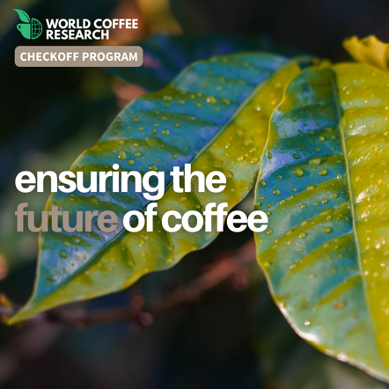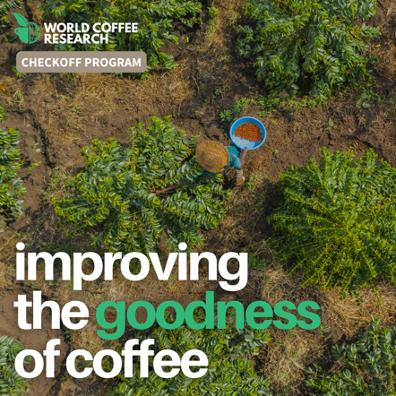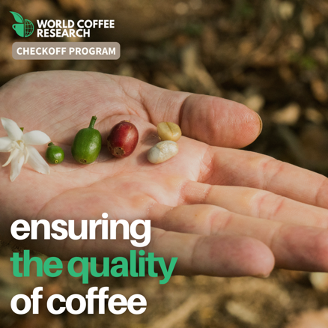
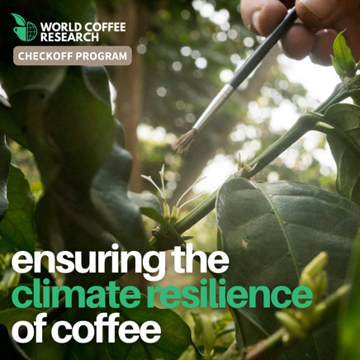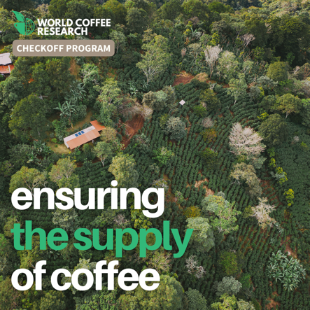
We're proud to do our part to ensure the future of coffee by matching WCR Checkoff Program donations. You can become a WCR member and help unleash the power of coffee varieties to meet coffee’s biggest sustainability challenges. Join here: https://worldcoffeeresearch.org/membership/checkoff-program
Agricultural science improves the goodness of coffee—how good it tastes, how good it is for the planet, and how good it is for the people who grow it. You can be part of making coffee better by becoming a WCR member. Sign up to donate pennies per pound (cents per kilo) to coffee research here: https://worldcoffeeresearch.org/membership/checkoff-program
Innovation is behind great coffee—donate pennies per pound (cents per kilo) to @WCoffeeResearch through the Checkoff Program. Join: https://worldcoffeeresearch.org/membership/checkoff-program
Roasters: The challenges facing coffee are bigger than any one company can solve alone. Support the future of coffee w/ every $ you spend with us. Sign up to give pennies per pound (cents per kilo) to @WCoffeeResearch. Join here: https://worldcoffeeresearch.org/membership/checkoff-program
Each time you buy green coffee from us, you can help ensure the future of coffee by donating pennies per pound to @WorldCoffeeResearch through the Checkoff Program. Become a WCR member here: https://worldcoffeeresearch.org/membership/checkoff-program
Research conducted today will determine what coffee we drink coffee. @WorldCoffeeResearch’s work is crucial to the future of our industry, and we’re proud to support them as a participating Checkoff importer. To help safeguard coffee amid pressing challenges like climate change and disease, all you have to do is sign up for Checkoff Program, and you’ll automatically donate pennies per pound to World Coffee Research each time you buy coffee from us. Sign up here: https://worldcoffeeresearch.org/membership/checkoff-program
Coffee needs your help: With threats like climate change and disease threatening our favorite crop, innovation of the coffee plant is needed now more than ever. Luckily, @WCoffeeResearch is stepping up to the challenge, working hard to ensure the future of coffee. We’re proud to support them through the Checkoff Program, and you can too. When you sign up for the WCR Checkoff program, you’ll automatically donate pennies per pound (cents per kilo) to World Coffee Research each time you buy coffee from us. You’ll be buying coffee and ensuring the future of coffee at the same time—how great is that?! Sign up here: https://worldcoffeeresearch.org/membership/checkoff-program
This [Earth Day / International Coffee Day / National Farmers Day], do something amazing for the farmers that are at the foundation of our entire industry. Support @WCoffeeResearch and their work to make better plants available and accessible to farmers to enhance coffee productivity, profitability, quality, and climate resilience. Sign up for the Checkoff Program today to contribute to coffee science each time you buy green coffee from us. Become a steward of the future of coffee! https://worldcoffeeresearch.org/membership/checkoff-program
Real-life example post from a participating Checkoff importer
